Project Development Phase
Model Performance Test

Date | 10 February 2025
Team ID | SWTID-2026-6670
Project Name | Implement Client Script & UI Policy (Incident)
Maximum Marks

Model Performance Testing:
Project team shall fill the following information in model performance testing template.
S.No. | Parameter | Values | Screenshot
 | Model Summary | No AI/ML model is used in this project. The solution is a rule-based ServiceNow configuration: UI Policy "High Impact Control" plus onChange, onSubmit and onCellEdit Client Scripts on the Incident table. | 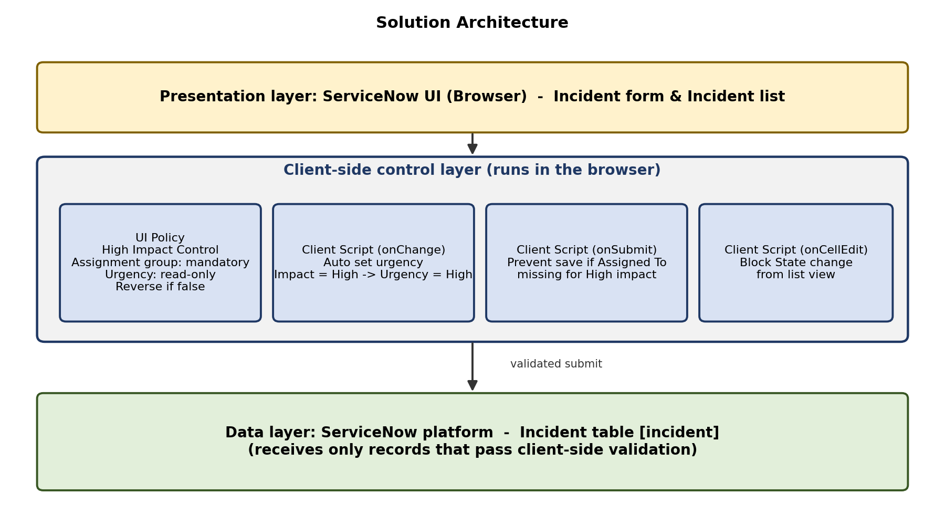
 | Accuracy | Training Accuracy - Not applicable (no trained model)  Validation Accuracy - Not applicable (no trained model)  Equivalent measure: UAT test pass rate = 9 / 9 = 100% | 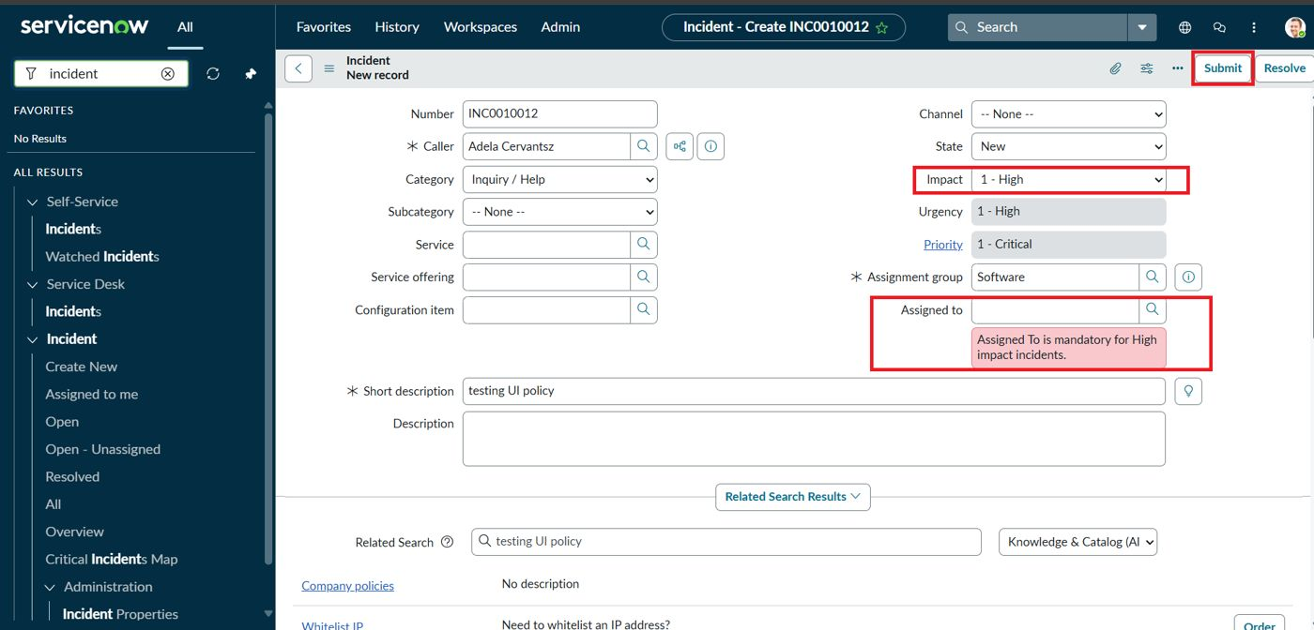
3. | Fine Tunning Result( if Done) | Validation Accuracy - Not applicable. Refinement done instead: onChange and onCellEdit scripts and the documentation were aligned (BG-001 to BG-003). | 